|  | INTERNATIONAL TELECOMMUNICATION UNION  **TELECOMMUNICATION STANDARDIZATION SECTOR**  STUDY PERIOD 2022-2024 | | | **Focus Group on Autonomous Networks (FG-AN)** |
| --- | --- | --- | --- | --- |
| **AN-I-296** |
| **Original: English** |
| **Question(s):** | | NA | | February 2023 (TBC) |
| **INPUT DOCUMENT** | | | | |
| **Source:** | | Indian Institute of Technology, Bhilai | | |
| **Title:** | | Report on activities for Build-a-thon 2022 from AI_ML_SSD team | | |
| **Contact:** | | Debanka Giri, Project Scientist, IIT Delhi | E-mail: debanka.giri@cse.iitd.ac.in | |
| **Contact:** | | Sudev Kumar Padhi, Ph.D., IIT Bhilai, India | E-mail: sudevp@iitbhilai.ac.in | |
| **Contact:** | | Mohit Kumar, B.Tech, IIT Bhilai, India | E-mail: mohitkumar@iitbhilai.ac.in | |
| **Contact:** | | Dr. Sk Subidh Ali  Mentor | E-mail: subidh@iitbhilai.ac.in | |

| **Keywords:** | Deep learning, Long Short Term Memory, Deep neural Network |
| --- | --- |
| **Abstract:** | This contribution provides a report on activities by the AI_ML_SSD team towards the Build-a-thon 2022. We analyze the Indian Institute of Technology Delhi use cases, “Slip Detection (and Force Estimation)” and “Object Detection” in a robotic arm, and produce a design as per the reference design in the Build-a-thon repository. We also provide the corresponding code based on the reference code in the Build-a-thon 2022 repository. After analyzing the use cases, we trained two ML models, one for “Slip Detection (and Force Estimation)” and another one for “Object Detection." We have tested and validated the models for the use cases. A demo video of the simulation of the robotic arm picking up the object is also given for reference, and how the use cases “Slip Detection (and Force Estimation)” and “Object Detection” are estimated by our ML models. |

**Scope**

This document provides a report on the analysis of the Indian Institute of Technology Delhi use cases “Slip Detection (and Force Estimation)” and “Object Detection.” The report includes the following:

* Analysis of the use case with examples
* A design of the use case
* Code to produce the graph-based design based on neo4j per the reference code provided in the Build-a-thon repo.
* Demo Video (with caption)
* Screenshots of Models and simulator
* ML Model architectures used
* Accuracy and hyperparameters of the Models

# References

[FGAN-use cases] ITU-T Focus Group Autonomous Networks Technical Specification “Use cases for Autonomous Networks” <https://www.itu.int/en/ITU-T/focusgroups/an/Documents/Use-case-AN.pdf>

[Build-a-thon 2022] <https://github.com/vrra/FGAN-Build-a-thon-2022>

[FG AN Arch framework] Architecture framework for Autonomous Networks, <https://www.itu.int/en/ITU-T/focusgroups/an/Documents/Architecture-AN.pdf>

[ Demo Videos] <https://drive.google.com/drive/folders/1Vih2QWYcVxqYS6VP-sjBcO-28p7mEaP8?usp=sharing>

[Code] <https://github.com/ITU-AI-ML-in-5G-Challenge/ITU-ML5G-PS-010-AI_ML_SSD-BYOC-Build-your-own-Closed-loop>

[TabNet] [TabNet: Attentive Interpretable Tabular Learning](https://arxiv.org/abs/1908.07442)

[IITD use case] <https://bhartischool.iitd.ac.in/build_a_thon/index.html>

# Abbreviations and acronyms

This document uses the following abbreviations and acronyms:

FC Fully-Connected

BN Batch Normalisation

GLU Gated Linear Unit

LSTM Long Short Term Memory

DNN Deep neural Network

ML Machine Learning

MEC Multi Edge Computing

SVM- Support Vector Machine

# Conventions

None

# Introduction

Allegro Hand is a robotic hand that can do things like pick up an object, hold it down, grasp it, paint, etc. To do the tasks listed above, we need an operator who wears a haptic glove that controls how the allegro hand moves. This makes a closed loop between the allegro hand and the haptic gloves. When the haptic gloves send a command, the allegro hand gets the message and does what the command says it should do. Then the feedback is sent by the allegro hand to the haptic gloves based on which new command is sent, and this way the closed loop continues. There is an Edge Computing Infrastructure between closer to the allegro hand that receives the command and feedback from the haptic gloves and allegro hand so that we can control the allegro hand remotely, acting as an interface between the allegro hand and the haptic gloves system. An allegro hand is used to work remotely, like changing cables on towers at high altitudes. The operator with the haptic glove here is the cable guy who fixes the cable. Even a critical task, like performing an operation, can be done remotely using an allegro hand, while the operator with the haptic glove here is a doctor. So, various tasks need different operators, which will control the allegro hand. So the issue that arises now is that the different operators need to learn how to control haptic gloves for various tasks, which is tough to learn and master. Along with this problem, there is a delay in communication between the haptic glove and the allegro hand because the feedback from the haptic gloves has to go through the Edge Computing Infrastructure. This makes the action that the allegro hand does take longer than it would have. This issue becomes very critical when we are doing tasks like performing an operation because the uncertain delay in the feeds to the allegro hand can misinterpret the command sent by the haptic gloves, causing mishaps. With the development of technology, especially machine learning, a machine learning model can take the place of different operators and do all the tasks that need to be done. Different operators have to do several smaller tasks with the haptic gloves to finish a given task, such as changing a cable, performing an operation, etc., which machine learning models can now do. We found that haptic gloves often do two of these subtasks to control the allegro hand, and that machine learning models can improve them and make them less dependent on the operator. ML models can also detect when there is a delay and only send commands after getting the right feedback from the allegro hand. This keeps the allegro hand from misinterpreting the commands, making it safe to perform critical tasks as the chances of any accidents are significantly reduced.

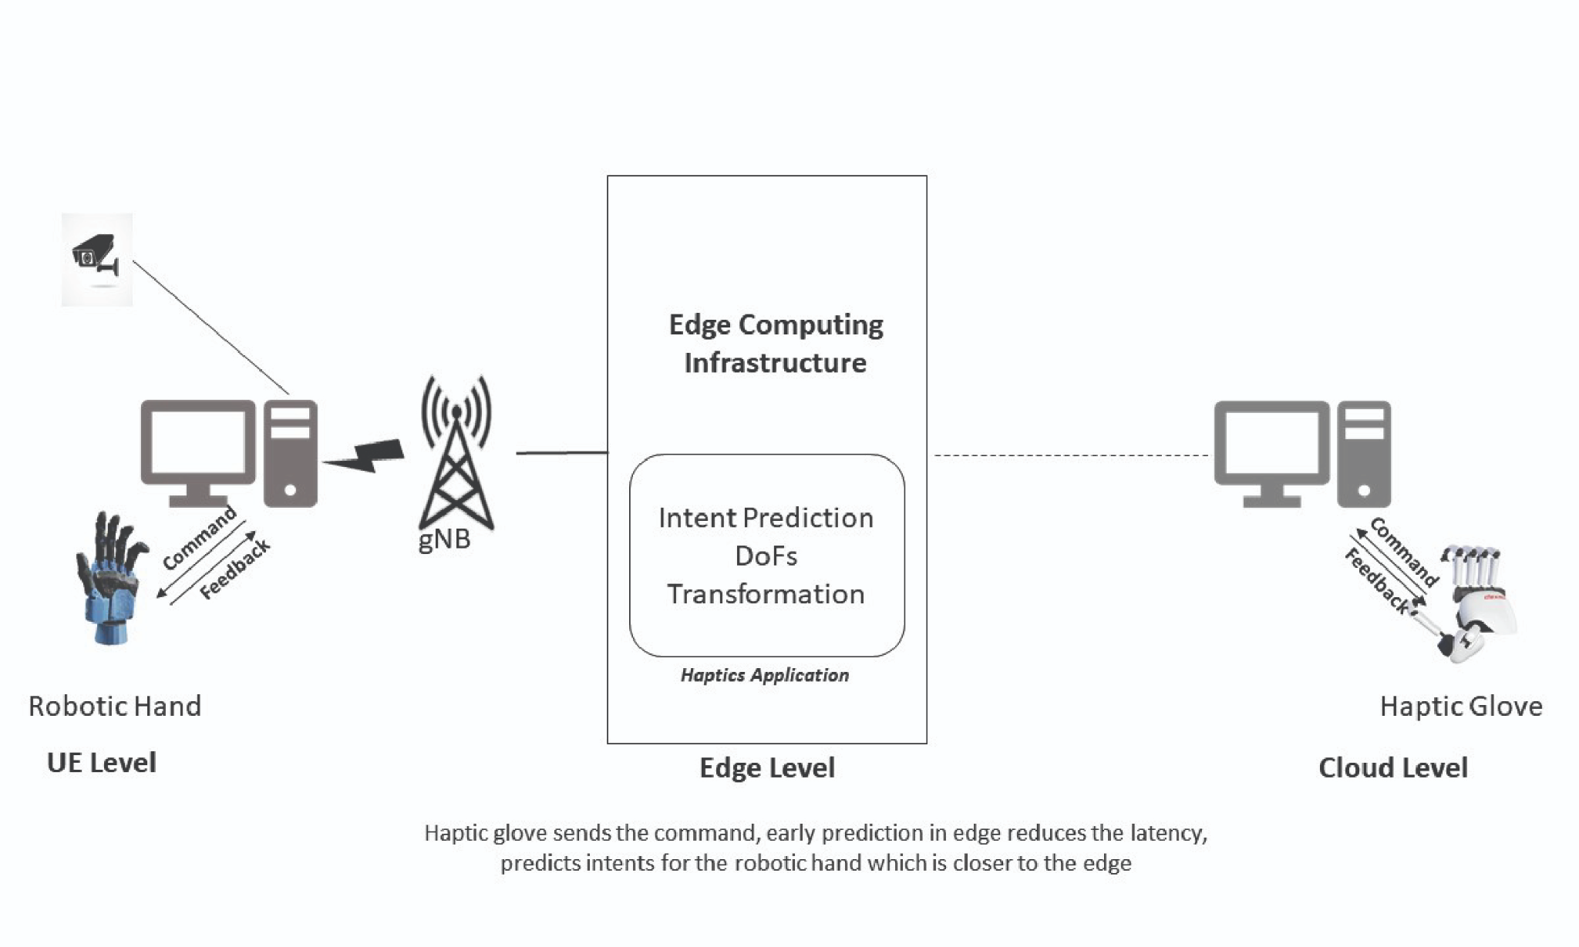

[ref:<https://bhartischool.iitd.ac.in/build_a_thon/index.html> ]

**Figure 1: Allegro hand and Haptic Glove setup in a closed loop.**

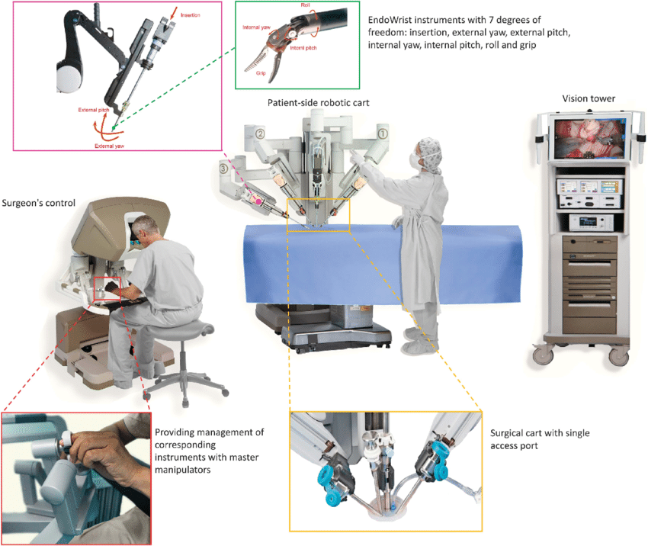

**Figure 2: Surgery operation using allegro hand and haptic Glove setup in a closed loop.**

The Allegro hand consists of three fingers and one thumb. Each of these fingers and thumbs has four actuators that give it the torque and angle of rotation it needs to hold an object. There are sixteen actuators in all. So when an operator is doing any activity with the haptic hand, which controls the allegro hand, we can get the force and angle. Force and angle, along with other parameters that depend on the object the Allegro hand interacts with, are used to train the machine learning model.

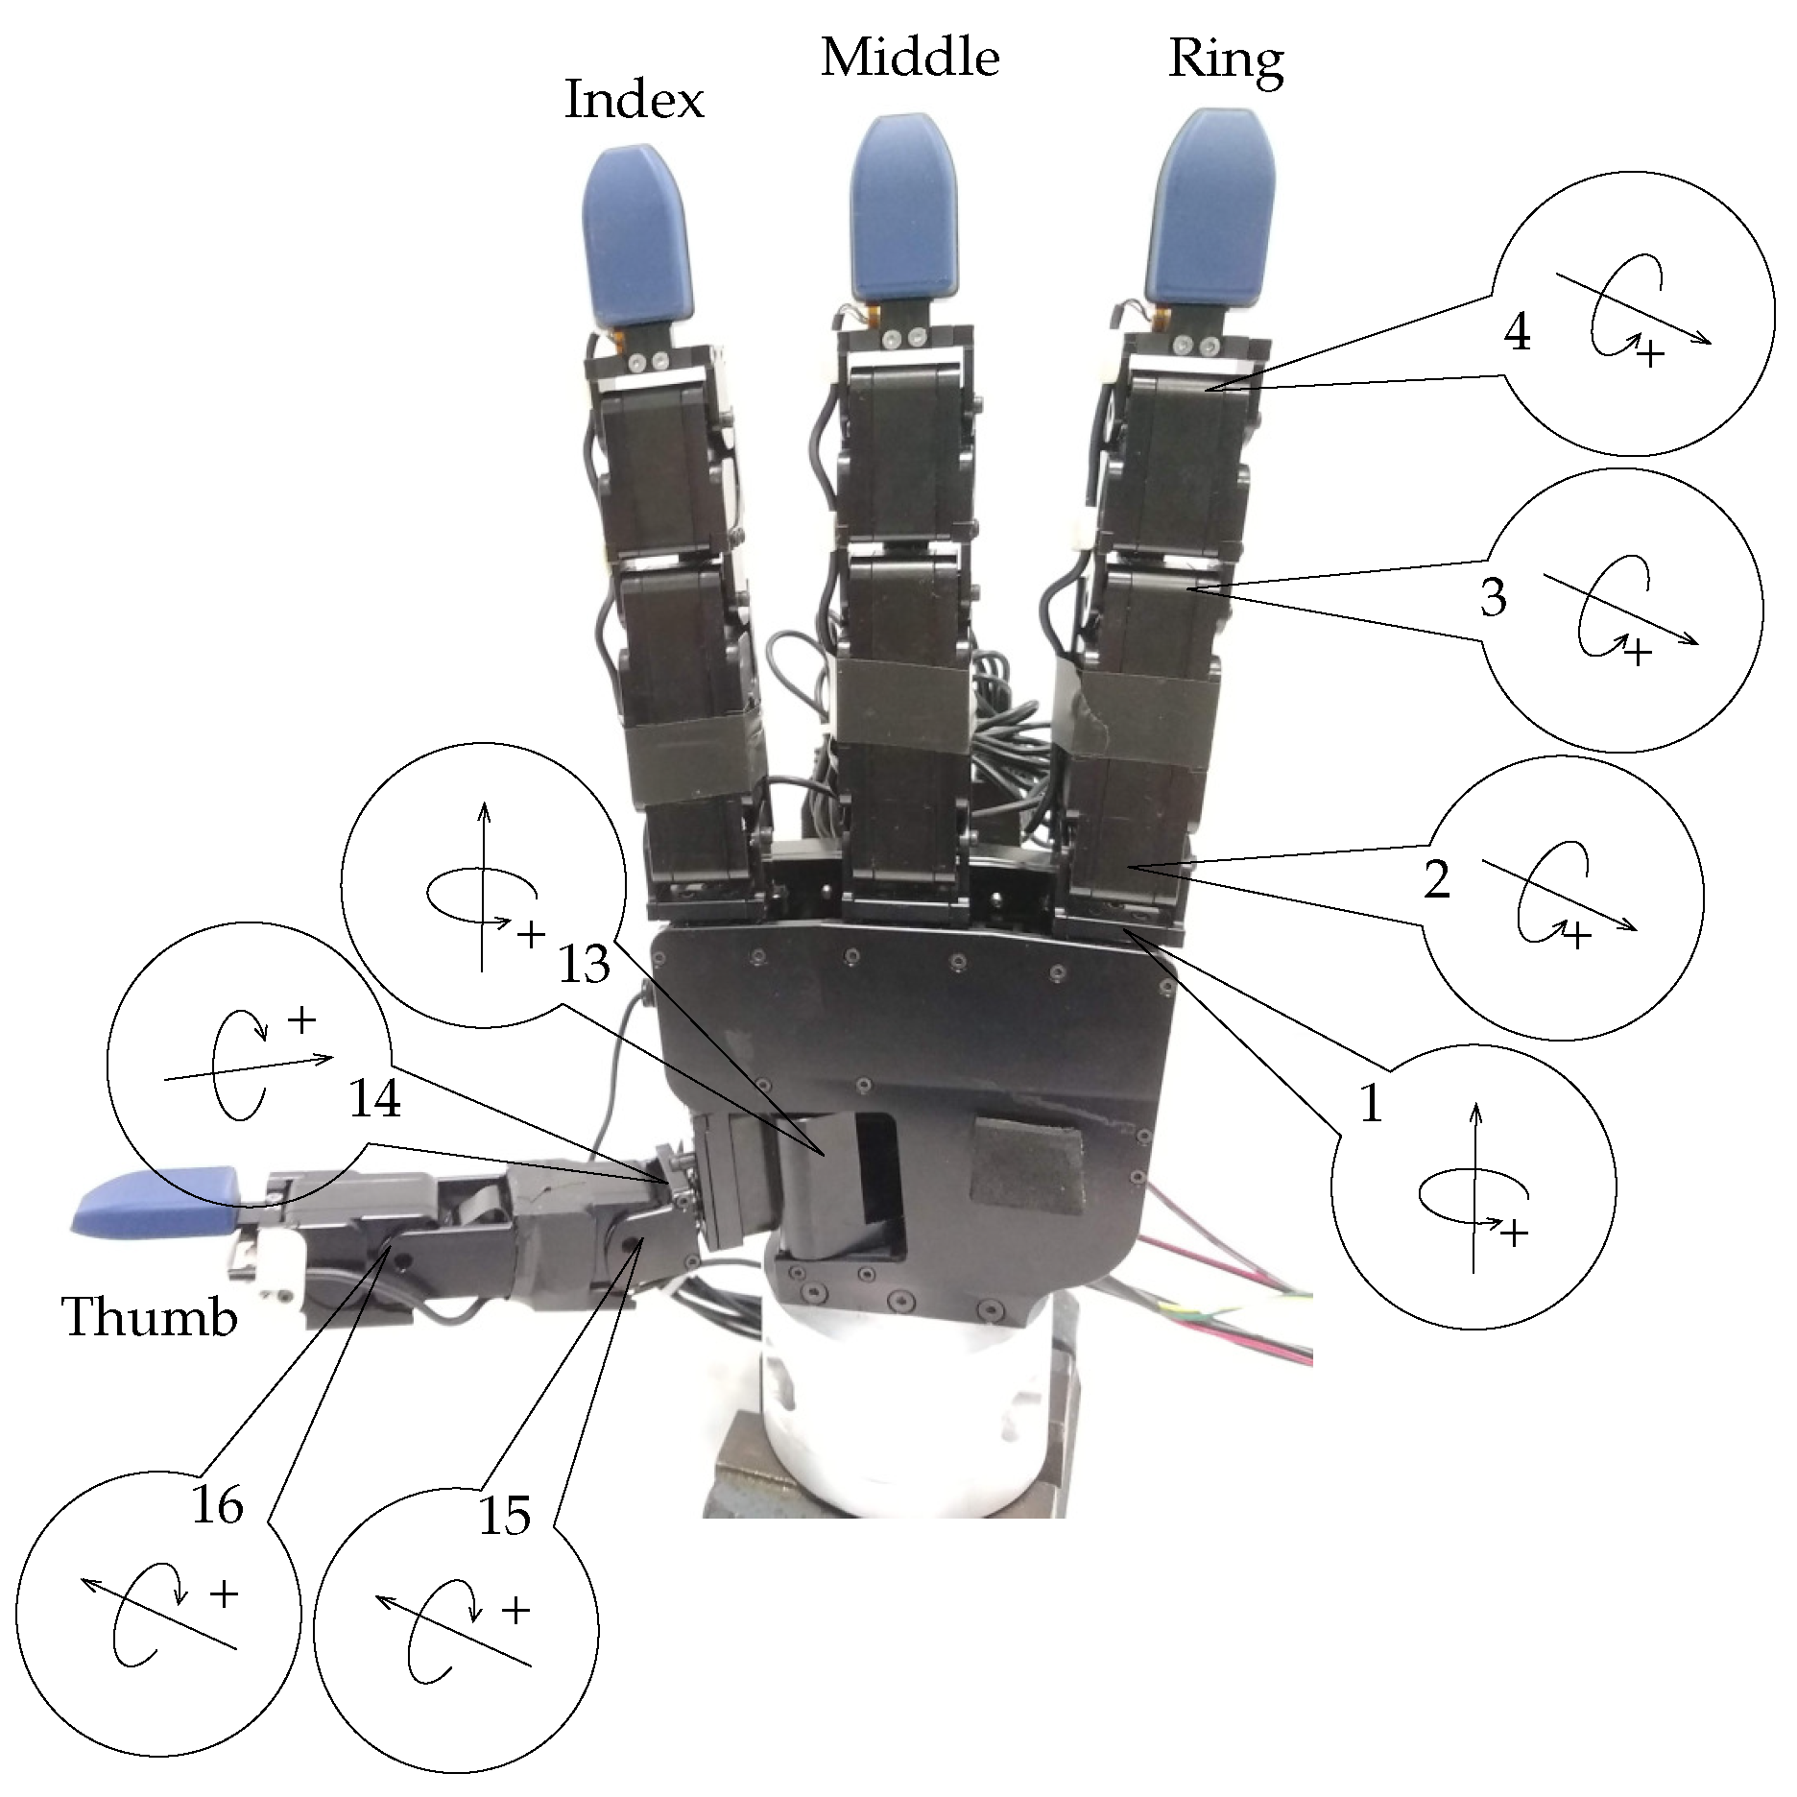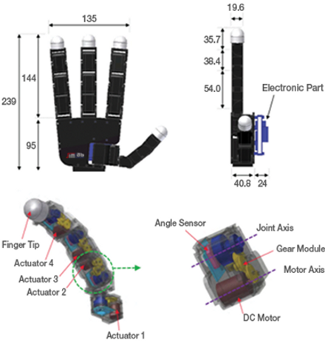

[ref:<https://www.mdpi.com/2218-6581/8/4/86/htm>, <https://www.wonikrobotics.com/research-robot-hand> ]

**Fig 3: Description of an Allegro Hand**

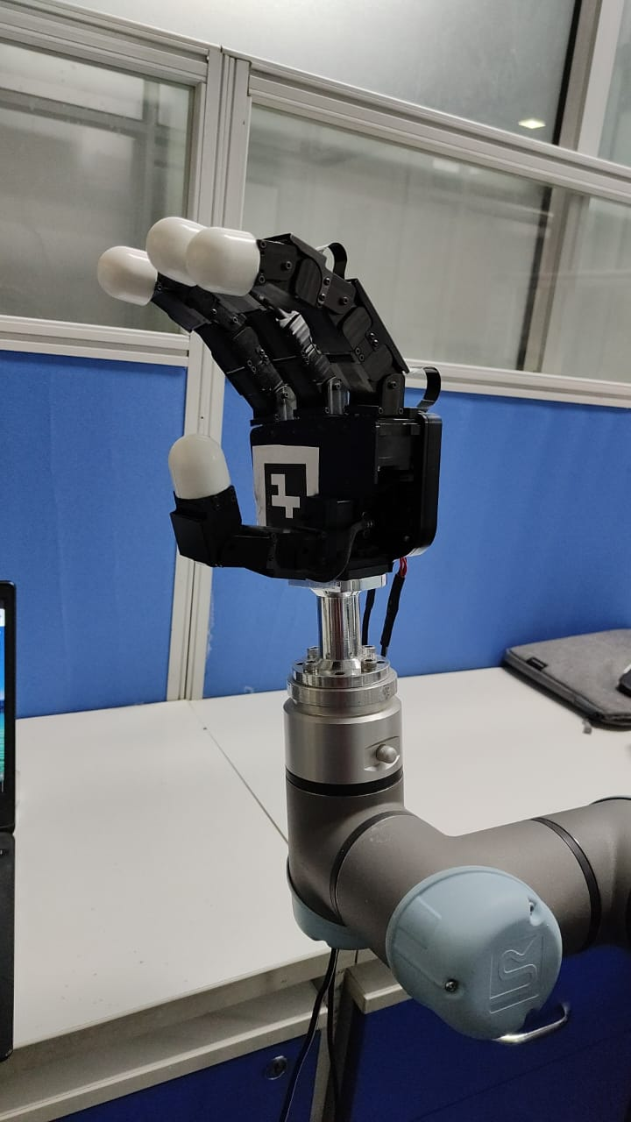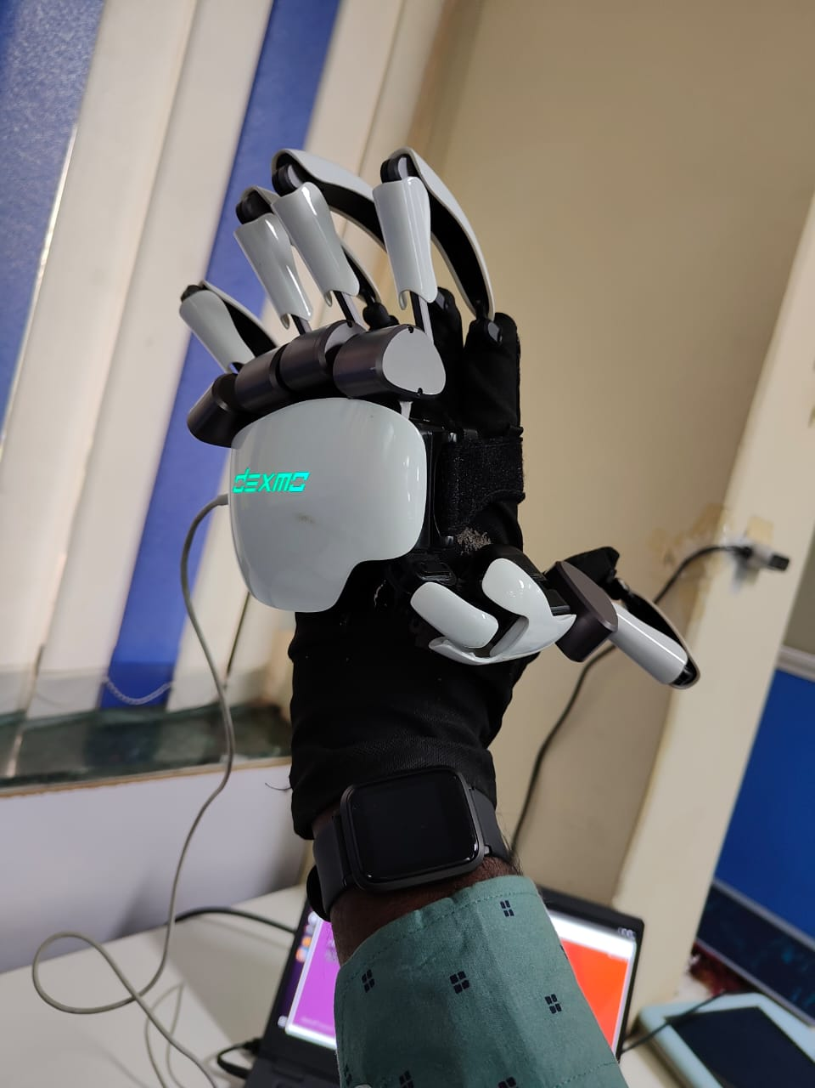

**Fig 4: Allegro hand (Left) and Haptic Gloves (Right) in test bed.**

**Fig 5: MEC setup to control allegro hand remotely.**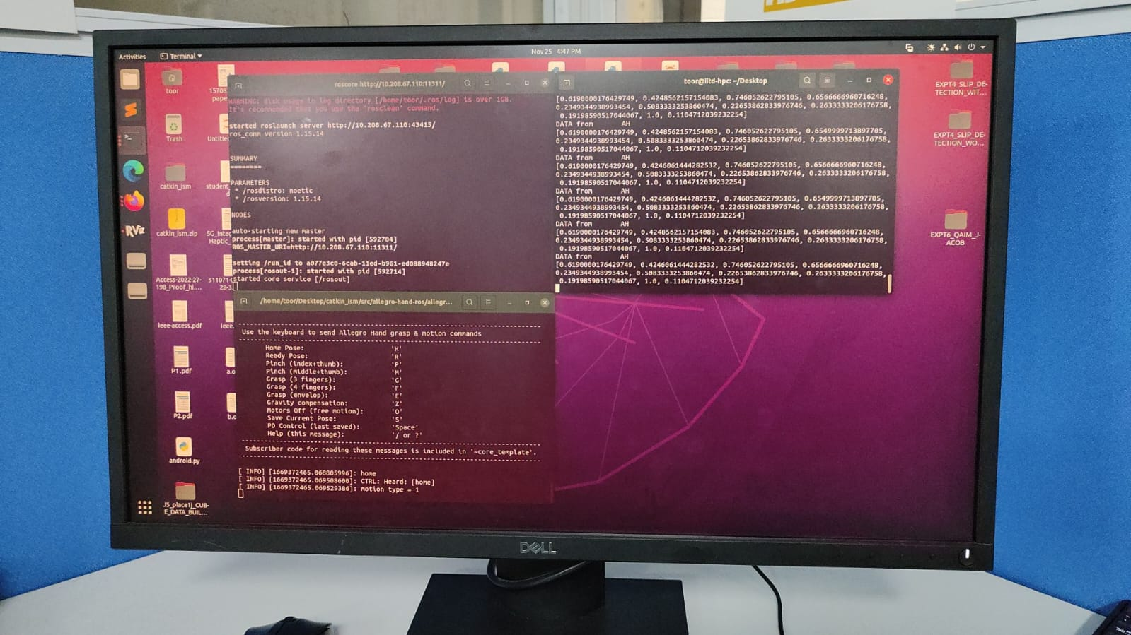

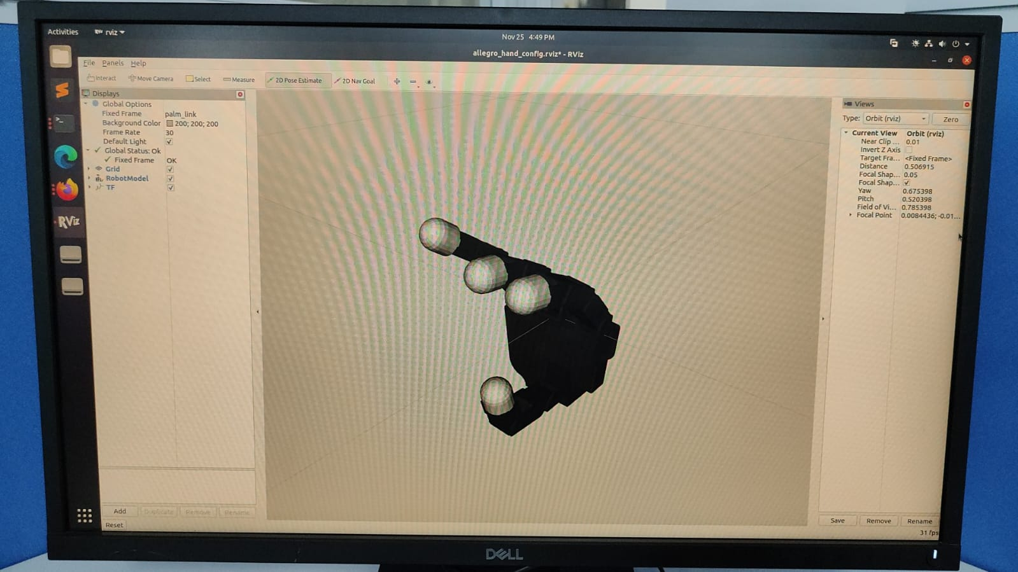

**Fig 6: 3d Model of allegro hand for simulation.**

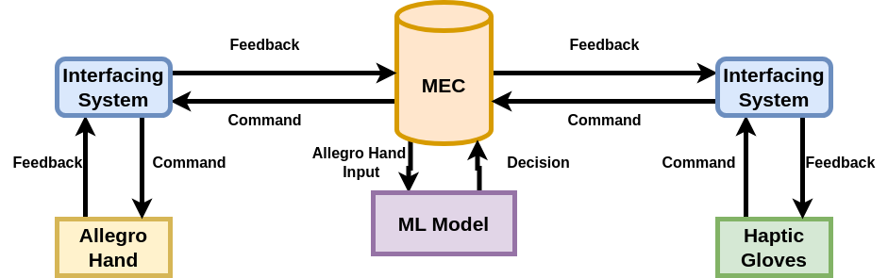

**Fig 7: Use of ML in controlling Allegro Hand in closed loop.**

Humans use tactile sensing to keep an object from falling or getting crushed when they grab it. Many researchers are interested in replicating the same behavior with a robotic arm. Detecting whether an object is slipping or crumpling is thus dependent on a variety of parameters, including the number of actuators in the robotic arm, the mass of the object, its shape, and so on. In the literature, there are many such models that have tried to accomplish the task of tactile sensing, but there is still no generalized model. Initially, models such as SVM were used to detect object slipping, but the robotic arm used here had a tac pin sensor with pins in the fingers, and as the object slipped, more pins became free, allowing the slipping of the object to be detected. However, because there were multiple fingers and multiple pins per finger, the calculation for detection was complex and yielded low accuracy. So a camera was also used along the tac pins for slip detection, but using camera is not the solution as camera cannot capture all the angles as covered by the arm. To make the camera cover all the angles, we will need multiple cameras, which will make the arm less flexible or useful. BioTac was used next to identify the slip detection, as it provides a skin like pattern that uses skip-related micro-vibrations to detect slip. The approach adopts a conservative estimate of the friction coefficient instead of estimating it on-the-fly. Some approaches also use sensors such as an accelerometer, an IMU (inertial measurement unit), or a force sensor attached so that the snapping of fingers can be used to detect if an object is slipping. Still, all of the mentioned approaches rely on the camera feeds to make accurate measurements, as using only the data from the sensors failed to achieve high accuracy. With the introduction of DNN for detecting slip, the accuracy began to rise constantly, but to a certain extent because the slip occurs for an instant only, and the DNN model was unable to generalize on that due to a lack of extracting the important features that are responsible for slip detection. Our proposed ML models can solve the problem of tactile sensing, which includes slip and crumple detection, and identify the shape of the object more accurately with sensor data alone without using any cameras. Due to the use of techniques we can identify important features, as well as make the Low Latency Closed Loop between the haptic gloves and allegro hand more robust by controlling delays and misinterpretation in the allegro hand.

There are two use cases identified based on the Low Latency Closed Loop between the haptic gloves and algorithms and the real robotic hand (Allegro Hand) using MEC. The problem statements solve the issue related to the application of tactile sensing in the allegro hand using the ML models.

1. **Slip Detection (and Force Estimation)**

Given an object being held by an allegro hand, the object may tend to slip from the grip. Using ML models, our goal is to figure out if the object is slipping out of our hands and getting crumpled. We take the time-series data of the Allegro hand, which includes the force and angle made by the Allegro hand's sixteen actuators with the object, as well as the mass and shape of the object. The values of slip and crumple can either be zero, which means the object is not slipping or crumpling. If the value is one, this means the object is slipping or crumpling. This output is provided for every instance of the given data. If an ML model can predict if the object is slipping and crumpling for every instance, then we can change the force and angle accordingly and make the hand balance the object. For the time being, the use case is to detect slip and crumple. Later, this approach can be extended to changing the force and angle to control the hand so the object is not slipping or crumpling using ML. Slip and crumple detection is very useful for many tasks. For example, if a wire is being connected remotely using the allegro hand, it may slip if not enough force is used to grip it, and if too much force is used, the object will be deformed, etc. The same things can be considered when performing an operation remotely.

1. **Object Detection**

The object is currently held by an Allegro hand. Our aim is to predict the shape of the object from 13 different shapes using an ML model. So, the ML model is given the force and angle that the object has on the sixteen actuators of the Allegro hand, as well as the mass of the object. The shape of the object could be a sphere, cube, or cuboid with different dimensions. This is very helpful because if the allegro hand can figure out the shape of the object, it can easily grab it just right.

# Design

**Problem statement I: (Slip Detection and Force Estimation)**

The initial datasets consist of timestamp data that predicts slip, crumple, or both. We were given the angle and force of 16 critical points on a hand, as well as the mass and shape of the object, and the objective was to train a model to predict whether it would slip or crumple.

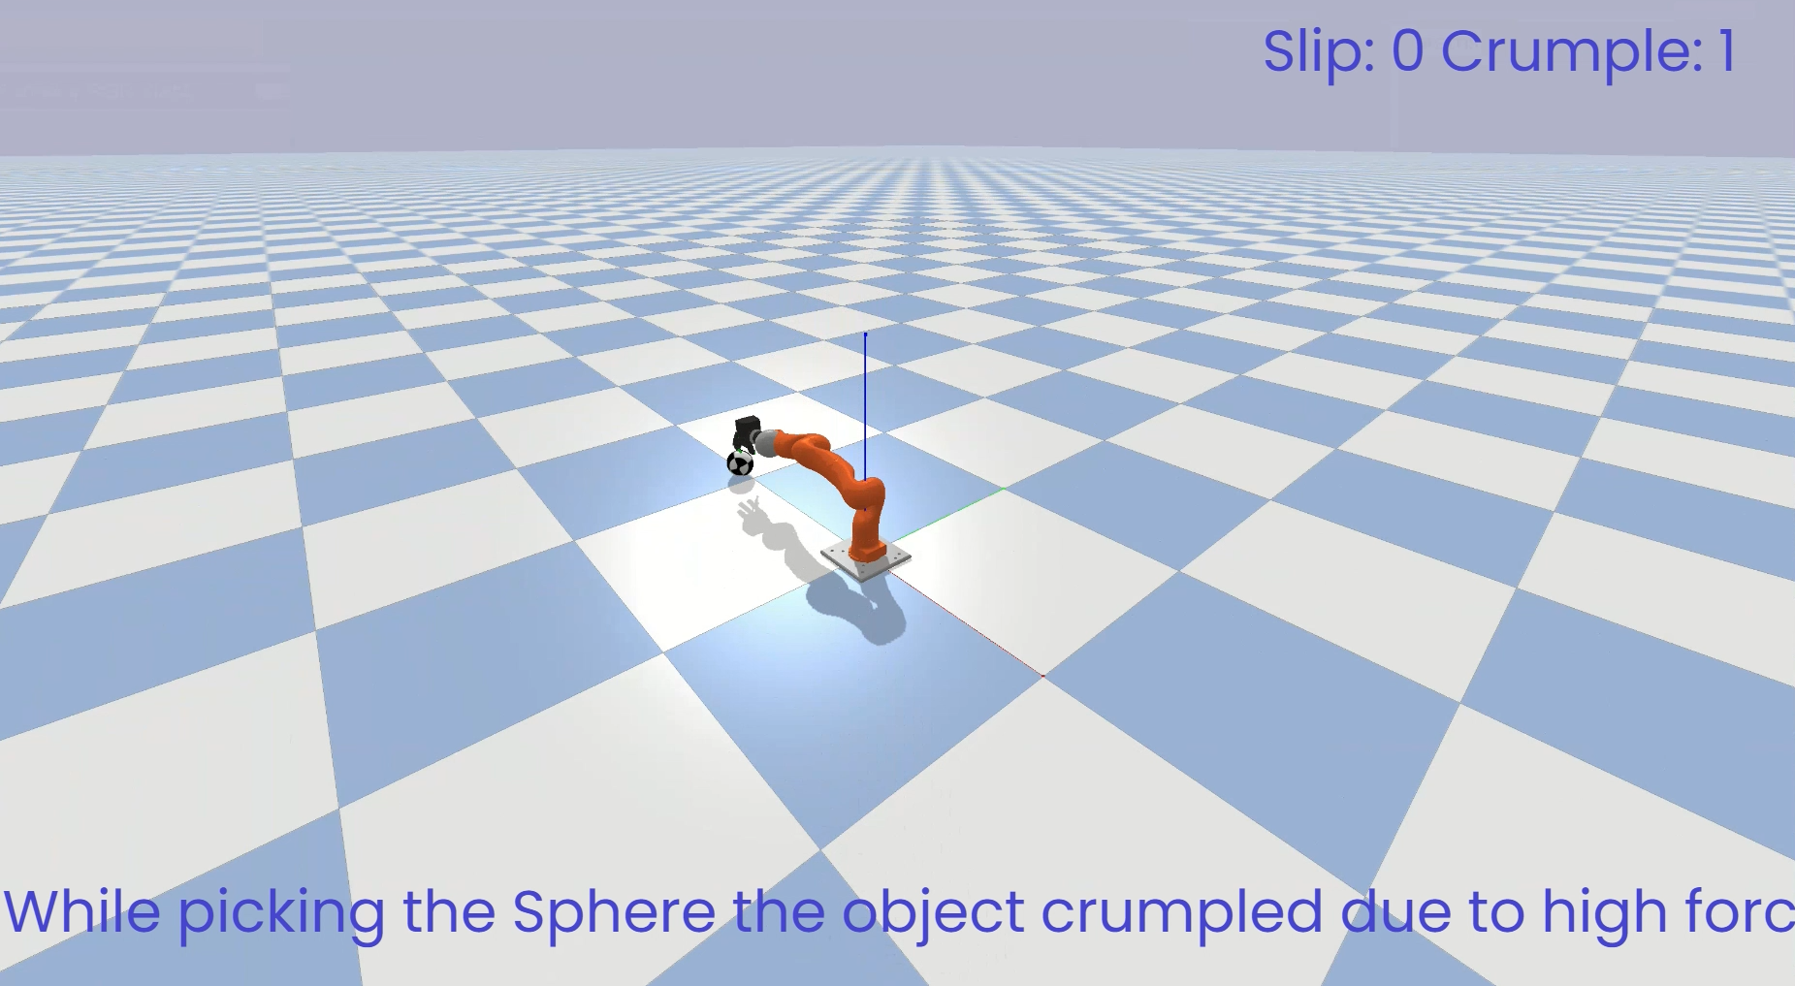

**Fig 8: Sphere is crumbled from the grasp.**

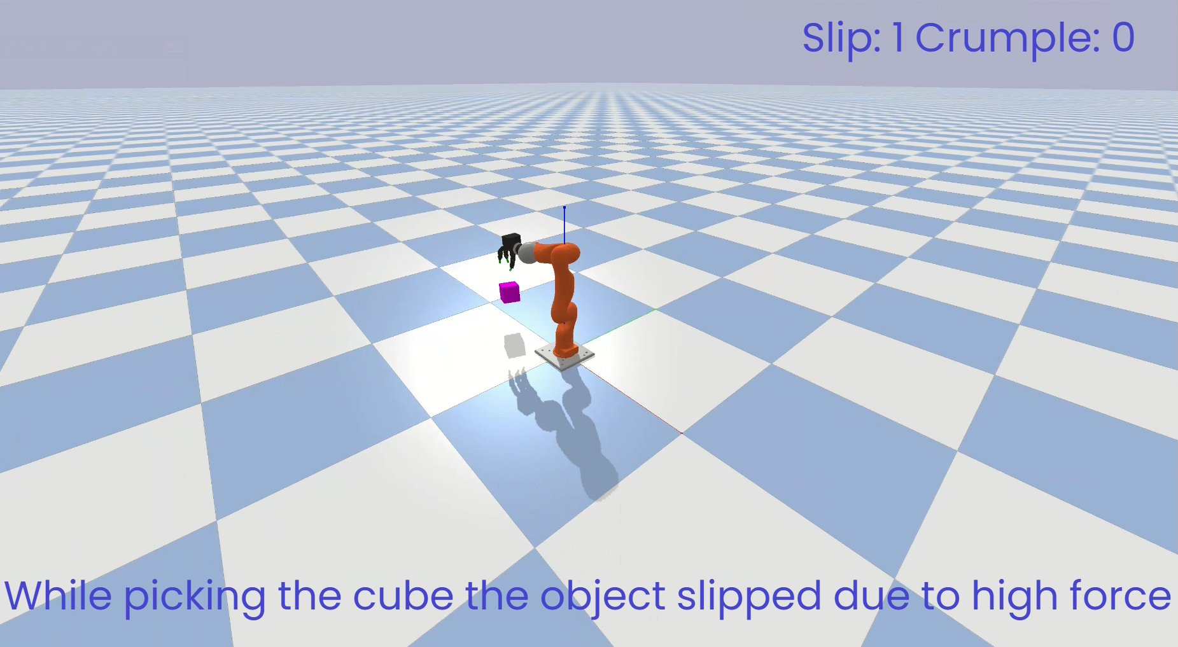

**Fig 9: Cube slipped from the grasp.**

**Feature Engineering**

The following are the steps we followed for feature engineering:

* The first thing we did was merge all the CSV files into a single file.
* Then we used a label encoder to encode the column named size as it contains alphabets, so we changed it to labels 0,1 and 2 for three object sizes, i.e., 5x10x5', 'R3.5' and '5x5x5.'
* Then we removed the timestamp column as we tried our approach both with and without the timestamp, and the latter method was more accurate.

**Note:** The dataset provided uses different timestamps for each event which makes the impact of timestamps less related to the output (slip or crumple).

* Then we divide the data into X and Y, where X is the data given to the model and Y is the actual output label for slip and crumple.
* Then, we scale the data with the min-max scaler.
* At last, we split the data into a train and test set by shuffling the data and giving the data to the model.

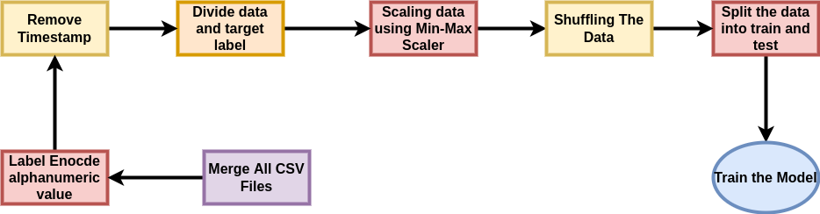

**Fig 10: Cleaning the Data for Problem Statement 1**

**Methodology**

**a) Experimental Methodologies Tried**

We have tried out simple DNN and LSTM-based models to classify slip and crumple. The simple DNN failed as the slip and crumple for a particular object occurred continuously, which was not captured by the simple DNN model. Then we moved on to the LSTM-based model as the data was continuous, but LSTM failed as the slip or crumple was occurring for a very small time frame and then state of slip and crumple changes at an instant, so building the relationships between slipping and crumpling of different types of objects was hard to form. Then we chose a model that was able to solve the problem by finding more dominant features, which gave us a higher accuracy.

To classify slip and crumple, we used a Multitask Classifier. With the help of a feature transformer, an attentive transformer, and feature masking, this model encodes the features. Then, the input features are encoded in a fully connected layer to find the best and most dominant set of features. For reasoning, we use multiple decision blocks, each of which focuses on processing a different subset of the input features.

Our model consists of the following modules:

* Feature transformer is composed of a fully-connected (FC) layer, BN (Batch Normalization), and GLU (Gated Linear Unit) nonlinearity which converts features into more interpretable attributes.

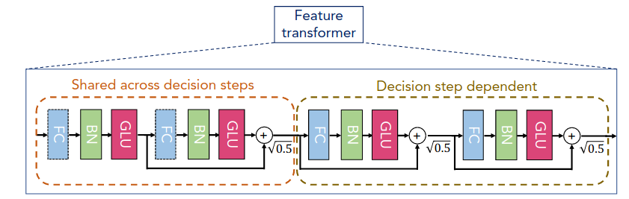

**Fig 11: Feature Transformer Block**

* Attentive transformer blocks consist of a single layer mapping modulated with prior scale information, aggregating how much each feature has been used before the current decision step. Here, the coefficients are normalized using sparsemax, leading to a sparse selection of prominent features.

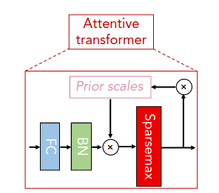

**Fig 12: Attentive Transformer**

* Feature selection mask gives interpretable information about the operation of the model, and the masks can be used to get the required global feature attribution.

Input features are passed through the feature transformer and attentive transformer before finding the feature selection mask. Then, on finding the mask, the encoded features are again passed on to the feature transformer. A split block divides the processed representation to be used by the attentive transformer of the subsequent step as well as for the overall output, which is passed onto the Relu function. This is performed three times, and all the outputs of these layers are added and passed on to a fully connected layer.

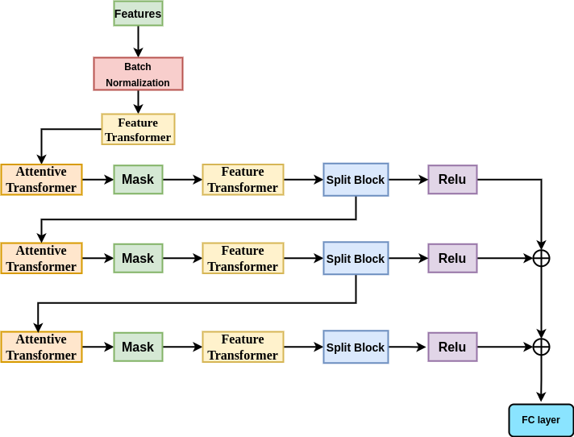

**Fig 13: Architecture of proposed model for Problem Statement 1**

**Note:** We have also used simple deep neural networks, LSTM, to train, but the accuracy of the proposed model was highest due to the reason that it encodes the features into a more meaningful entity, which correlates to the output labels more.

**b) Hyperparameter Space** (Learning rate, Model type, Optimization Scheme)

Framework used - Pytorch

Learning rate- 0.02

Optimizer - Adam

Loss Function - CrossEntropy

Momentum - 0.02

Model Type - Deep Neural Network

Epochs - 100

Validation Split - 0.16 percent of whole data

Batch Size - 2048

**Note:** We used 100 epochs as we had employed early stopping, and after 100 epochs the accuracy was not improving, rather it was going down.

**c) Training Results**

| **Models** | **Proposed**  **Model** | **DNN(5 layers)** | **DNN(10 layers)** | **LSTM** |
| --- | --- | --- | --- | --- |
| **Validation accuracy** | **93.2** | 86.2 | 87 | 89.4 |
| **Training Accuracy** | **93.7** | 87 | 87.5 | 90.1 |
| **Loss** | **0.13521** | 0.26 | 0.23 | 0.18 |

**Table 1: Models tried for Problem Statement-1**

**Note:** We have chosen the model with the highest accuracy and lowest loss.

**Problem statement II: (Object Detection)**

The initial datasets provided consist of data that predicts the object's shape. The dataset includes the position and force of 16 key points on a hand, as well as the weight of the object. This data provided is used to train a model to detect the shape of the object.

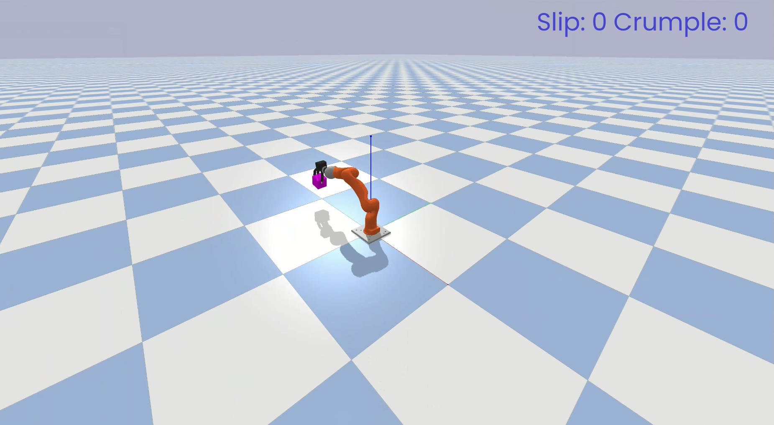

**Fig 14: Hand Picked up the object to identify the shape as cube.**

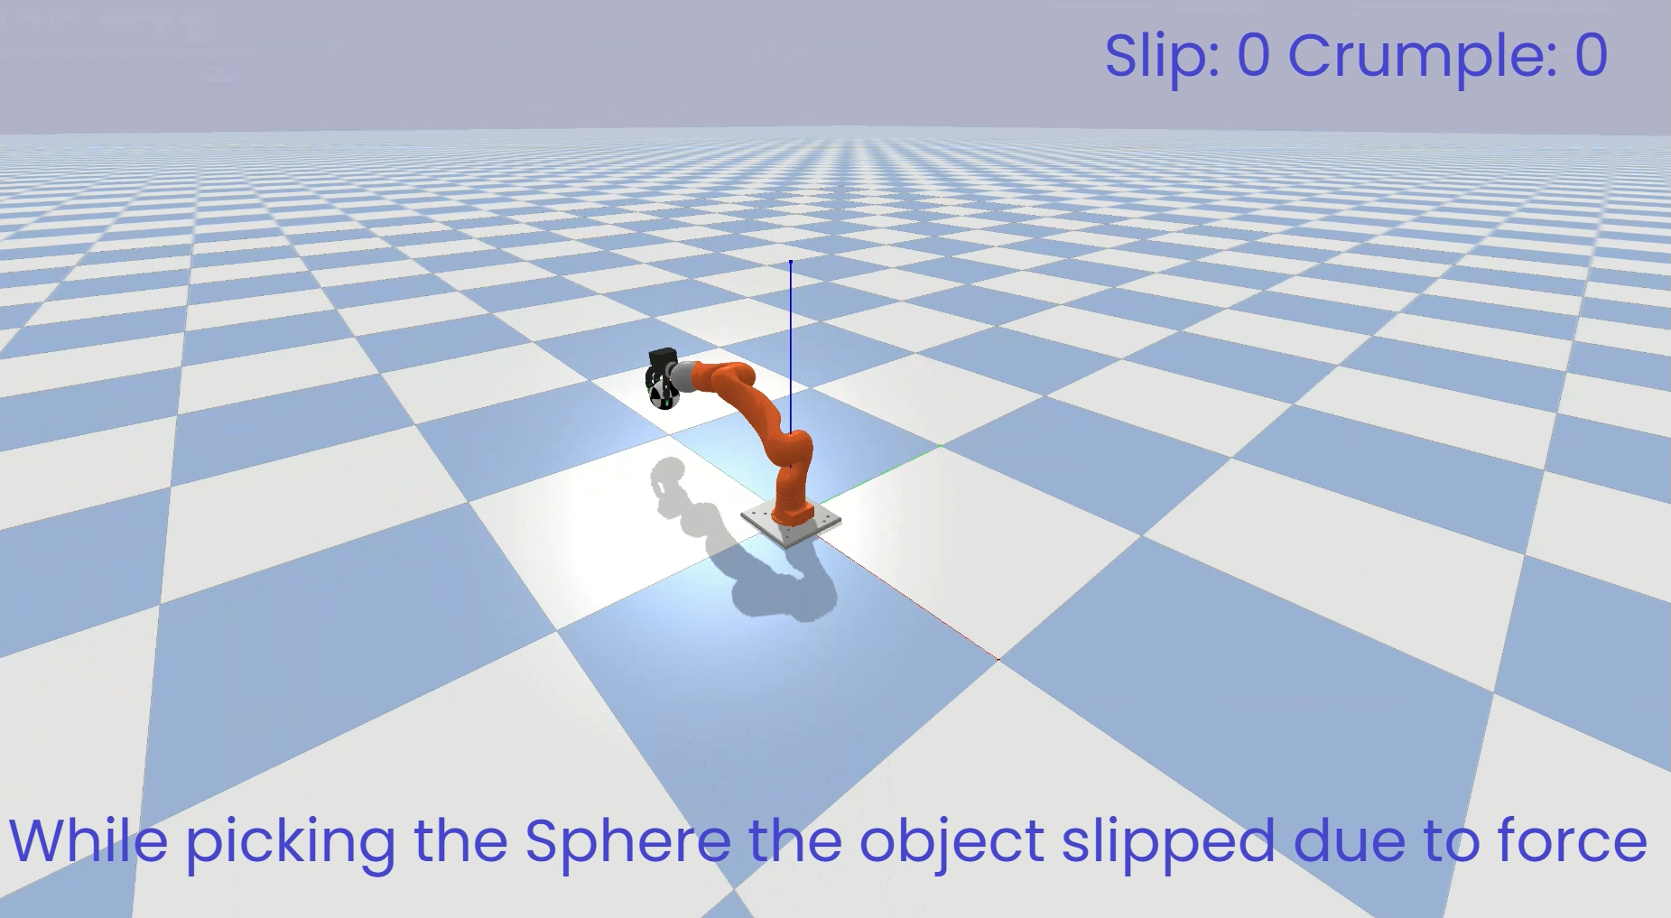

**Fig 15: Hand Picked up the object to identify the shape as shpere.**

**Feature Engineering**

Following are the steps we followed for Feature Engineering:

* First, we used a label encoder to encode the column Object_Held, which consists of the shape of the objects. It contains alphabets, so we have changed it to labels 0 to 12 for the 13 different objects' shapes.
* Then we split the data as X and Y, where X is the data that will be given to the model and Y is the actual output label of the object shape.
* Then, we scale the data with the min-max scaler
* Then we shuffle the data and split it before giving the data to the model.

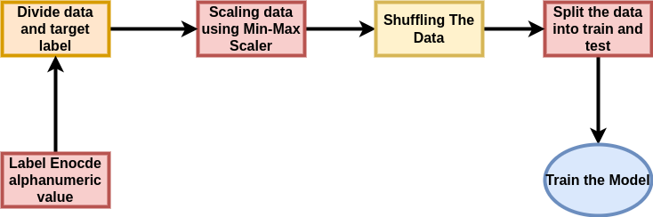

**Fig 16: Cleaning the Data for Problem Statement 2**

**Methodology**

**a) Experimental Methodologies Tried**

The model we used is a simple Deep Neural Network that consists of 5 fully connected (FC) layers. We have used 10-fold cross-validation to increase the accuracy and get the best parameters. We tried out other models but didn't get any drastic improvement, and this small model was giving similar results, so we went with the smaller model. To choose the final model, we tweaked the number of nodes in the layers and got the best result.

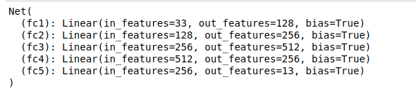

**Fig 17: Architecture of proposed model for Problem Statement 2**

**b) Hyperparameter Space** (Learning rate, Model type, Optimization Scheme)

Framework used - Pytorch

Learning rate- 0.002

Optimizer - Adam

Loss Function - CrossEntropy

Model Type - Deep Neural Network

Epochs - 200

Validation Split - 10 Fold validation

Batch Size - 2048

**Note:** We used 200 epochs as we had employed early stopping and after 100 epochs the accuracy was not improving, rather it was going down.

c) **Training Results**

| **Models** | **Proposed**  **Model** | **DNN(15 layers)** | **DNN(10 layers)** | **LSTM** |
| --- | --- | --- | --- | --- |
| **Validation accuracy** | **99.7** | 99.6 | 98.9 | 94.6 |
| **Training Accuracy** | **99.8** | 99.8 | 99.2 | 95.4 |
| **Loss** | **0.014** | 0.019 | 0.024 | 0.05 |

**Table 2: Models tried for Problem Statement-2**

**Note:** We chose a 5 layer deep DNN because it was a very simple architecture, but it was still performing very well compared to larger architectures.

# Code and demo

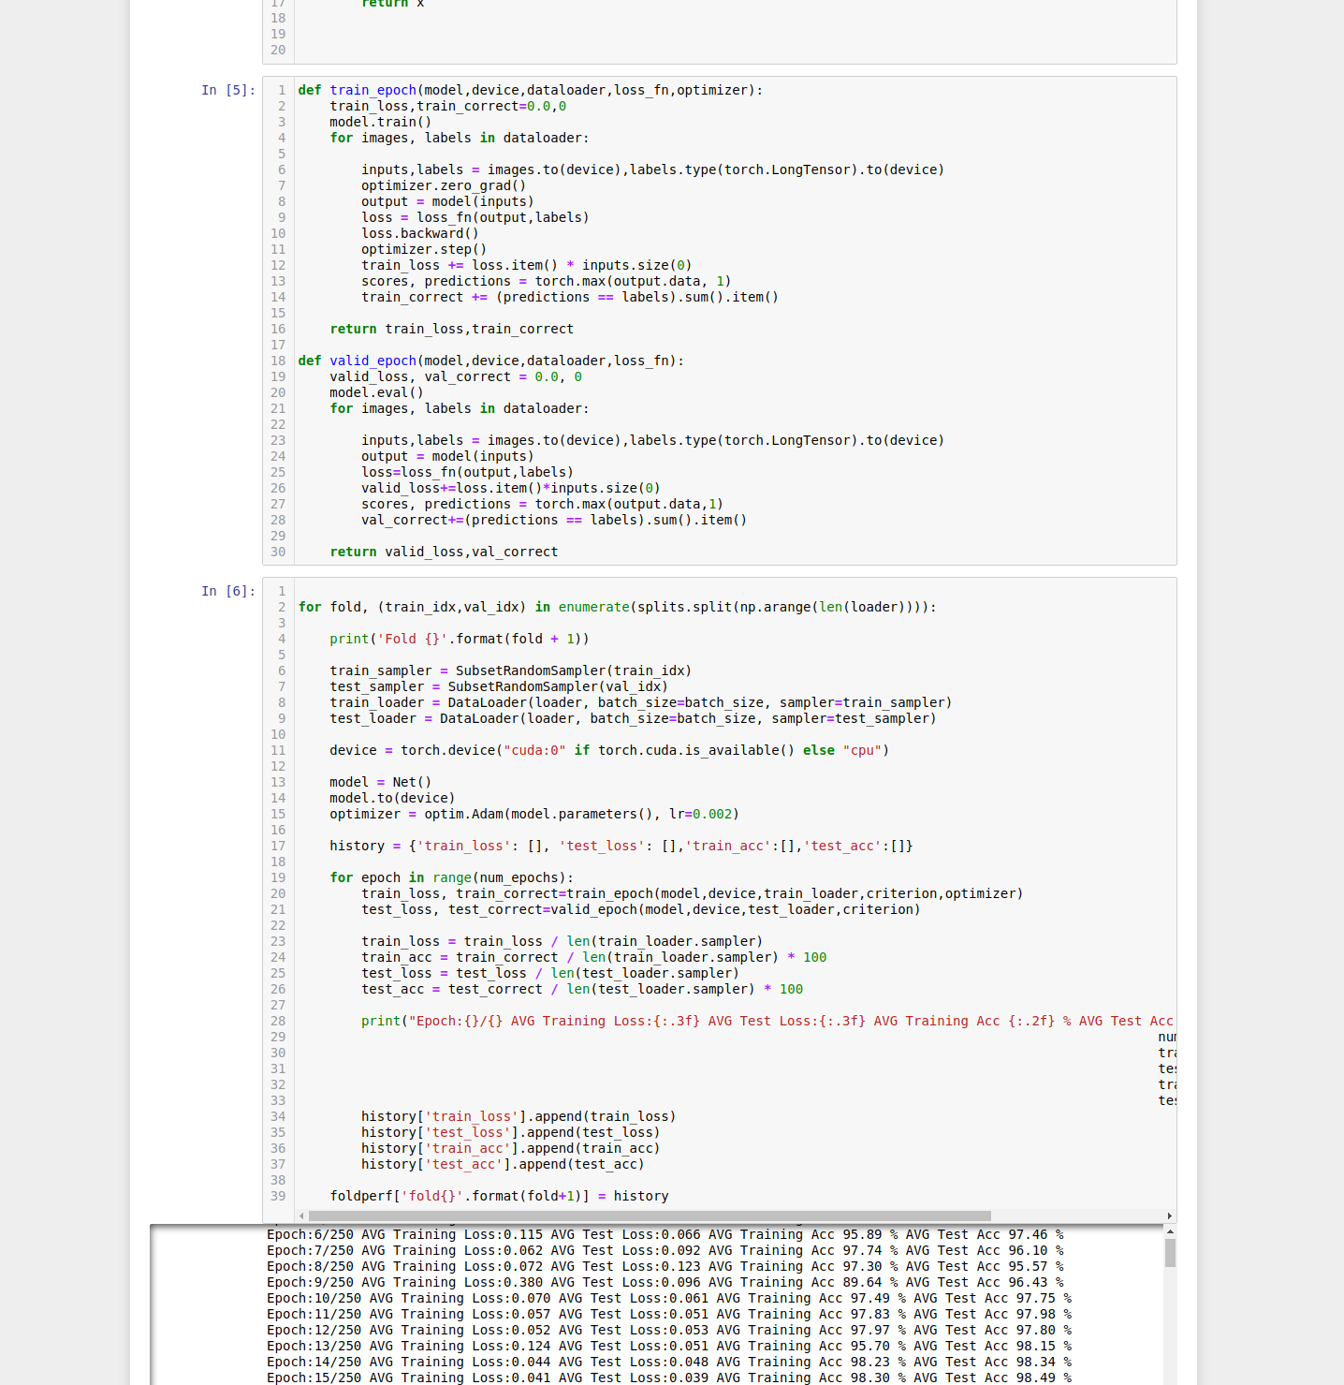

**Fig 18: Notebook for problem statement-1**

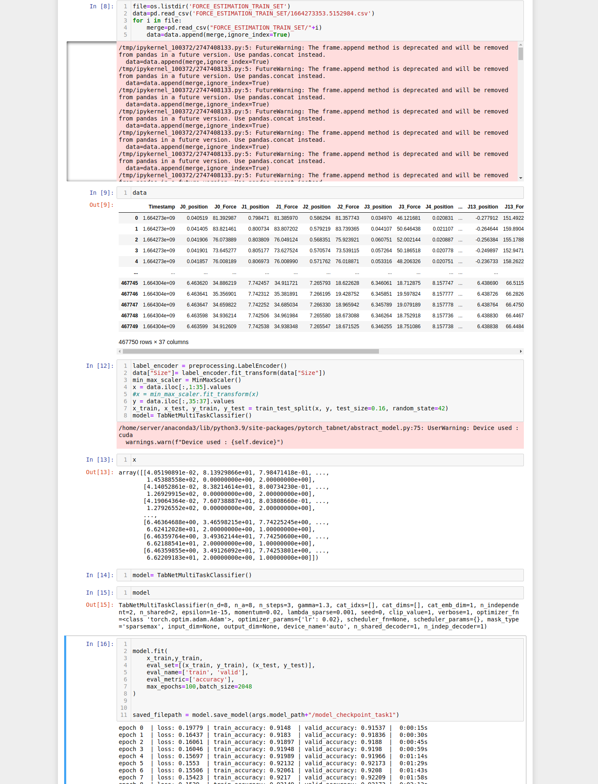

**Fig 19: Notebook for problem statement-2**

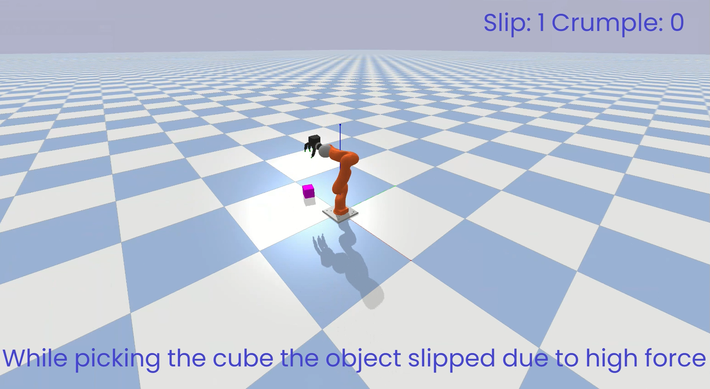

**Fig 20: Cube slipped from the grasp.**

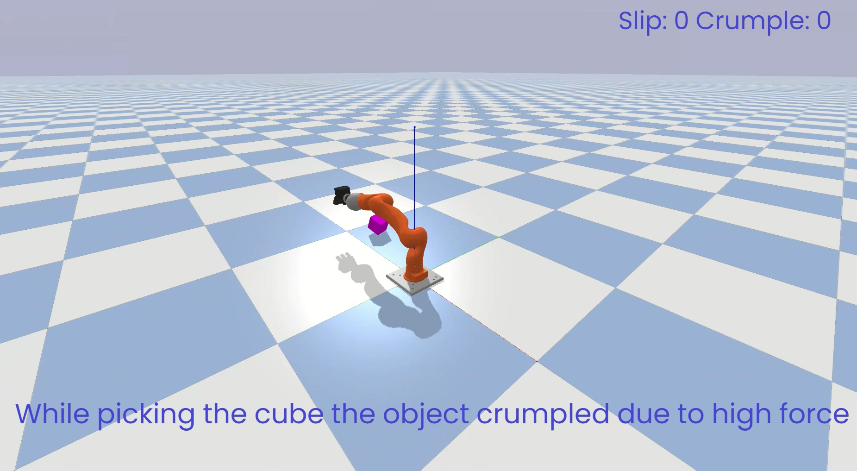

**Fig 21: Cube crumpling from the grasp.**

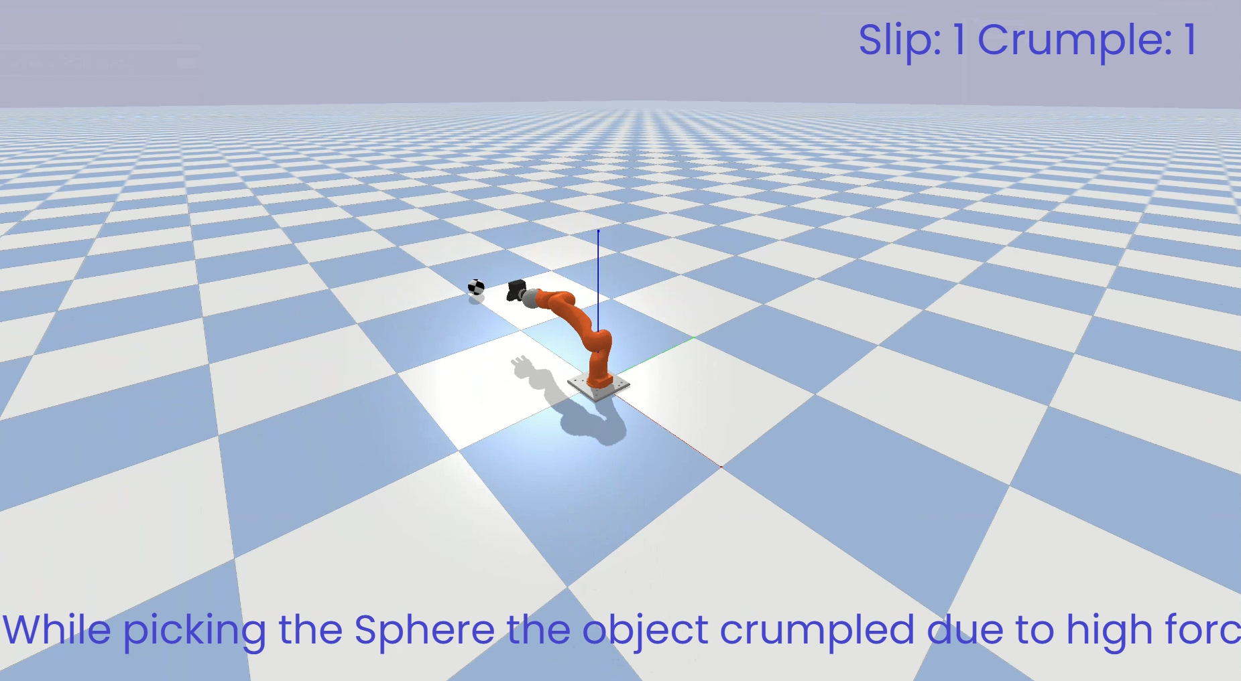

**Fig 22: Sphere crumpled from the grasp.**

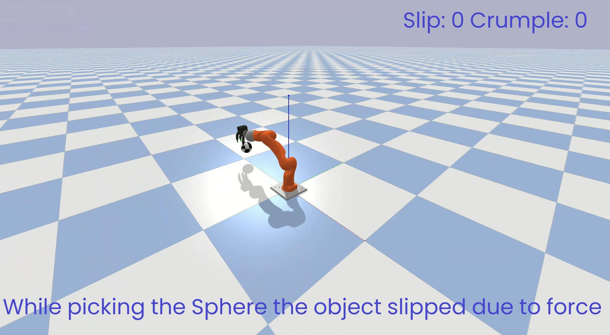

**Fig 23: Sphere Slipped from the grasp.**

app.create_actors_relationship_with_usecase("PS1 model", "outputs", "Slip ", "usecase_001")

app.create_actors_relationship_with_usecase("PS1 model", "outputs", "Crumple ", "usecase_001")

app.create_actors_relationship_with_usecase("Force OF Joints", "Inputs", "PS1 model", "usecase_001")

app.create_actors_relationship_with_usecase("Mass of object", "Inputs", "PS1 model", "usecase_001")

app.create_actors_relationship_with_usecase("Shape of Object", "Inputs", "PS1 model", "usecase_001")

app.create_actors_relationship_with_usecase("Time stamp", "Inputs", "PS1_model", "usecase_001")

app.create_actors_relationship_with_usecase("MEC", "outputs", "Time stamp", "usecase_001")

app.create_actors_relationship_with_usecase("MEC", "outputs", "Shape of Object", "usecase_001")

app.create_actors_relationship_with_usecase("MEC", "outputs", "Mass of object", "usecase_001")

app.create_actors_relationship_with_usecase("MEC", "outputs", "Force OF Joints", "usecase_001")

app.create_actors_relationship_with_usecase("Haptic Arm", "Inputs", "MEC", "usecase_001")

app.create_actors_relationship_with_usecase("Object", "Inputs", "MEC", "usecase_001")

app.create_actors_relationship_with_usecase("PS2 model", "outputs", "Shape of Object ", "usecase_002")

app.create_actors_relationship_with_usecase("Force OF Joints", "Inputs", "PS2 model", "usecase_002")

app.create_actors_relationship_with_usecase("Mass of object", "Inputs", "PS2 model", "usecase_002")

app.create_actors_relationship_with_usecase("MEC", "outputs", "Mass of object", "usecase_002")

app.create_actors_relationship_with_usecase("MEC", "outputs", "Force OF Joints", "usecase_002")

app.create_actors_relationship_with_usecase("Haptic Arm", "Inputs", "MEC", "usecase_002")

app.create_actors_relationship_with_usecase("Object", "Inputs", "MEC", "usecase_002")

**Note:** Code for the graph generation.

**Problem statement I: (Slip Detection and Force Estimation)**

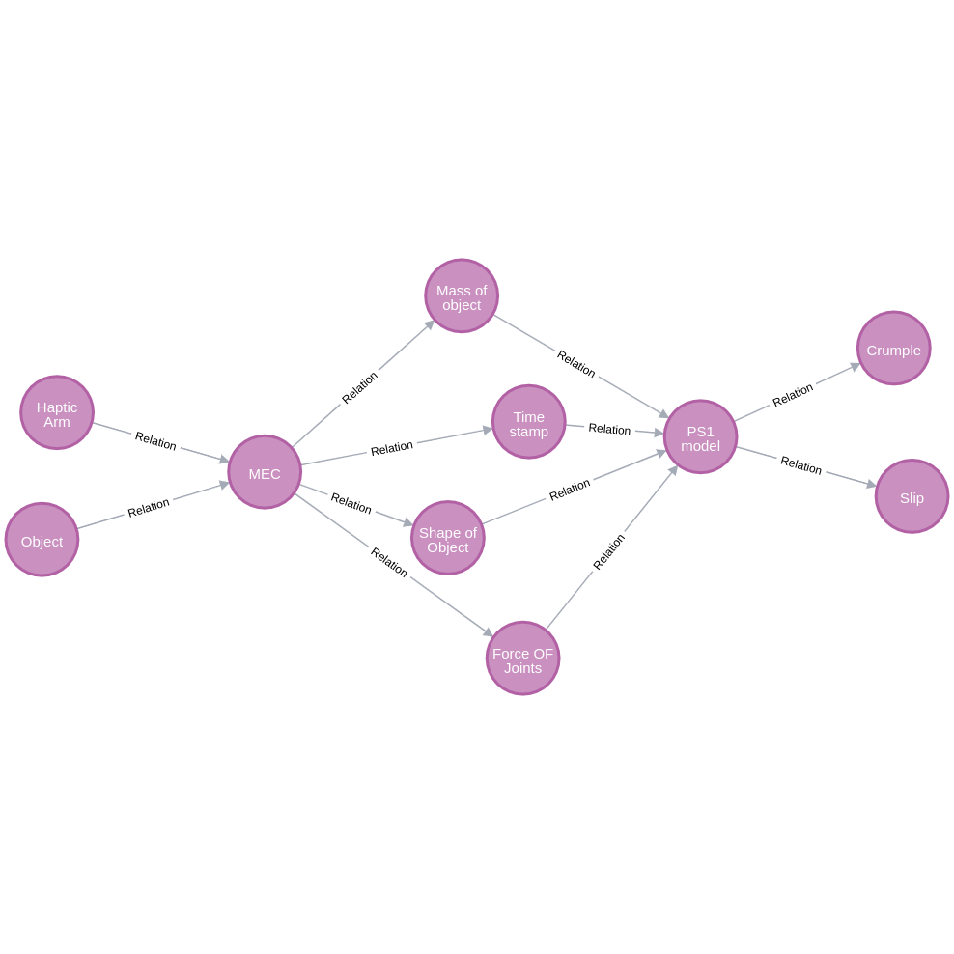

**Fig 24: Graph for problem statement-1**

| **Actor** | **Description** | **Relation** |
| --- | --- | --- |
| Haptic Arm | Gives force and angle to hold a object | Haptic Arm -> Inputs -> MEC |
| Object | Shape and mass of Object | Object -> Inputs -> MEC |
| MEC | Outputs the haptic arm and object information to the model | MEC-> outputs -> Time stamp |
|  |  | MEC-> outputs -> Shape of Object |
|  |  | MEC-> outputs -> Mass of object |
|  |  | MEC-> outputs -> Force OF Joints |
| Mass of Object | Mass of the Object | Mass of object-> Inputs -> PS1 model |
| Time Stamp | Time of event | Time Stamp -> Inputs -> PS1 model |
| Shape of object | Shape of the object | Shape of object Inputs -> PS1 model |
| Force of Joints | Force and angle made by haptic arm on object | Force OF Joints Inputs -> PS1 model |
| PS1 Model | Model which predict slip or crumple | PS1 model -> outputs -> slip |
|  |  | PS1 model -> outputs -> crumple |

**Table 3: Relationship table for Problem Statement-1**

**Problem statement II: (Object Detection)**

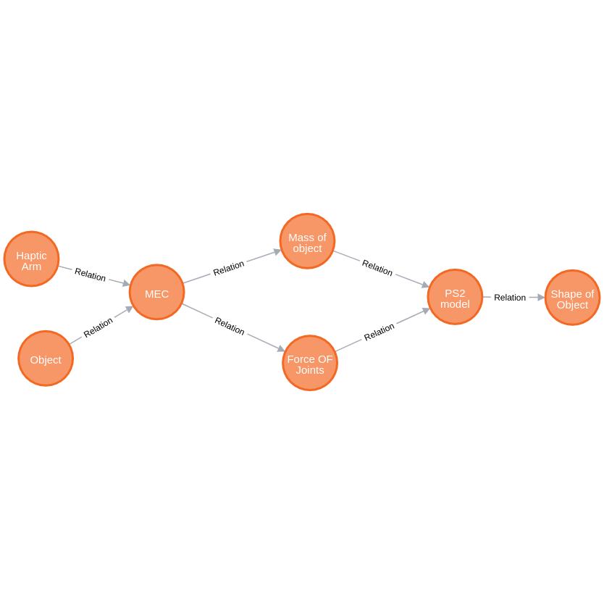

**Fig 25: Graph for problem statement-2**

| **Actor** | **Description** | **Relation** |
| --- | --- | --- |
| Haptic Arm | Gives force and angle to hold a object | Haptic Arm -> Inputs -> MEC |
| Object | Shape and mass of Object | Object -> Inputs -> MEC |
| MEC | Outputs the haptic arm and object information to the model | MEC-> outputs -> Mass of object |
|  |  | MEC-> outputs -> Force OF Joints |
| Mass of Object | Mass of the Object | Mass of object-> Inputs -> PS2 model |
| Force of Joints | Force and angle made by haptic arm on object | Force OF Joints Inputs -> PS2 model |
| PS2 Model | Model which predict slip or crumple | PS1 model -> outputs -> shape of object |

**Table 4: Relationship table for Problem Statement-2**

# Summary

In this document, we discussed the use case from Indian Institute of Technology Delhi and analyzed the design. We provide extensions to the reference code provided in [Build-a-thon 2022] and build our own graph based on the reference code.

The report includes the following:

* Analysis of the use case with examples
* A design of the use case
* Code to produce the graph-based design based on neo4j as per the reference code provided in the Build-a-thon repo.
* Demo Video (with caption)
* Screenshots of Models and simulator
* ML Model architectures used
* Accuracy and hyperparameters of the Models

_________________